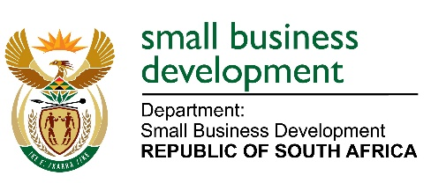

MEDIA ADVISORY

08 DECEMEBER 2022

TO ALL MEDIA HOUSES

DEPARTMENT OF SMALL BUSINESS DEVELOPMENT VISITS THE INTSIKA YETHU LOCAL MUNICIPALITY, EASTERN CAPE PROVINCE TO HANDOVER MACHINERY AND EQUIPMENT TO INFORMAL TRADERS

Minister of Small Business Development, Ms Stella Ndabeni-Abrahams, will lead a delegation of senior officials and programme managers from the Department of Small Business Development to handover equipment to informal business owners in the Eastern Cape Province on 09 December 2022.

The beneficiaries are part of the Department’s Informal and Micro Enterprises Development Programme which provides developmental support to small businesses that are mostly operating in townships and rural areas of South Africa. This initiative is a nationwide trajectory striving to accelerate the growth of informal and micro enterprises by improving their competitiveness and sustainability to become formal businesses in the mainstream economy. The focus is mainly on designated groups such as women, youth and people with disabilities.

Members of the media are invited as follows:

DATE : Friday, 09 December 2022
TIME : 12h00 – 15h00
VENUE : Intsika Yethu local Municipality at Town Hall.

End.
Enquiries:

Sendra Mashego: 063 645 6171 / smashego@dsbd.gov.za
Issued by the Department of Small Business Development

