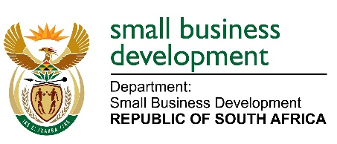

MEDIA ADVISORY

25 NOVEMBER 2022

MINISTER STELLA NDABENI-ABRAHAMS TO PRESENT A KEYNOTE SPEECH AT THE BMF PROFESSIONAL SMME AWARDS

The Minister of Small Business Development, Ms Stella Ndabeni-Abrahams is expected to deliver a keynote address at the 2022 BMF Professionals SMME Awards in East London on the 26th of November 2022.

The Department of Small Business Development (DSBD) is mandated to create an enabling environment for small businesses and cooperatives in the country for them to thrive but acknowledges that it is not a simple task unless it recognises the importance of partnerships in order to achieve this objective. The participation and involvement of DSBD in the BMF Professional SMME Awards signal another important partnership that enhances cooperation between government and various stakeholders in the private sector and non-governmental role players.

The Department of Small Business Development invites members of the media to cover the event and awards ceremony as follows:

Date: Saturday, 26 Nov 2022
TIME: 17H00 – 22H00
Venue: ICC East London

//End...

Enquiries: McIntosh Polela on 079 563 1625
Issued by the Ministry of Small Business Development

