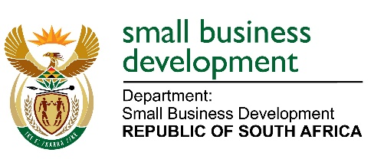

MEDIA ADVISORY

18 NOVEMBER 2022

TO ALL MEDIA HOUSES

MINISTER STELLA NDABENI-ABRAHAMS AND THE CHARLOTTE MANNYA-MAXEKE INSTITUTE HANDS OVER WORKING EQUIPMENT TO WOMEN OWNED SMMEs

Small Business Development Minister, Stella Ndabeni-Abrahams will be handing over business equipment to 24 mostly women owned small business beneficiaries at the Esincedeni Elderly Centre in Freedom Park, Soweto on Saturday 19 November 2022. This will be done in partnership with the Charlotte Mannya-Maxeke Institute (CMMI), as part of the “Bring Her Up Entrepreneurship program.”
Following the celebrations in 2021 after our government declared the year as The Year of Charlotte Maxeke, which was on her 150th commemoration, the Charlotte Mannya Maxeke Institute (CMMI) designed the BHU Entrepreneurship Program which is structured to equip women with necessary tools in life skill and entrepreneurship. The Women Empowerment program is an ongoing program that is targeting primarily unemployed women aged between 19 years - 35 years (and older), and the Gauteng Province leg includes areas such as Kliptown, Freedom Park (Soweto) and Chief Luthuli Township in Daveyton (Ekurhuleni). The Institute is guided by four pillars #LEEL – Leadership, Education, Empowerment and Legacy. For each pillar there is a program that aligns and speaks to it and the BHU program speaks directly to Empowerment with its core mandate being empowering women to take up spaces and promoting self-sustenance.

Minister Stella Ndabeni-Abrahams’ Department of Small Business and Development is one of the first departments to positively respond on the clarion call to honour Mme Charlotte Maxeke. The commitment by the Minister to cover 150 women will be achieved before the end of the 2022/23 financial year. The Charlotte Mannya Maxeke Institute has extended this initiative (BHU Program), to other provinces that are connected to the name, being KwaZulu Natal and soon to also extend to the Eastern Cape and Limpopo Province.

The support and contribution by the Department of Small Business and Development is aimed at ensuring the sustainability and success of women owned small businesses, and to assist them to create their own part to self-development.

Activities for the day will take place at two venues:
1. Bring Her Up Program - Handover,
Date: Saturday 19 November 2022
Time: 09h00-10h00
Venue: Esincedeni Elderly Centre Freedom Park Soweto
2. Mothers of the Nation
Time: 12h00- 14h00
Venue: The Maslow Hotel Rivonia Rd &, Grayston Sandton Jhb
Issued by the Ministry of Small Business Development and the Charlotte Mannya-Maxeke Institute
Enquiries: McIntosh Polela 079 563 1625
Nolwazi Maphumulo 065 903 7498 & Kimberly Nkuku 067 626 7339
End//…

