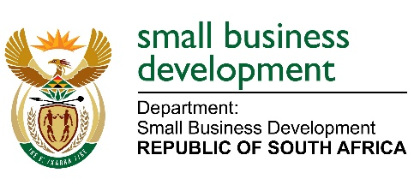

MEDIA ADVISORY

29 NOVEMBER 2022

THE DEPUTY MINISTER OF SMALL BUSINESS DEVELOPMENT, MR SIDUMO DLAMINI TO HANDOVER EQUIPMENT TO INFORMAL BUSINESSES IN THE KWAZULU-NATAL PROVINCE ON 05 DECEMBER 2022

The Deputy Minister of Small Business Development, Mr Sidumo Dlamini will in collaboration with Ugu District Municipality lead the handover of working material and equipment to informal traders of Ugu Disability Chamber in KwaZulu-Natal. The ceremony is part of the Department’s Informal and Micro Enterprise Development Programme (IMEDP).
The IMED Programme provides developmental support to small businesses that are mostly operating in townships and rural areas of South Africa. This initiative is a nationwide trajectory striving to accelerate the growth of informal and micro enterprises by improving their competitiveness and sustainability to become formal businesses in the mainstream economy. The focus is mainly on designated groups, i.e. women, youth and people with disabilities.

Members of the media are invited to cover the event as follows:
Date: 05 December 2022
Venue: Ugu Sports and Leisure, Portshepstone
Time: 10h00 – 14h00

Issued by the Department of Small Business Development
Enquiries: Ms Sendra Mashego
Mobile: 063 645 6171

